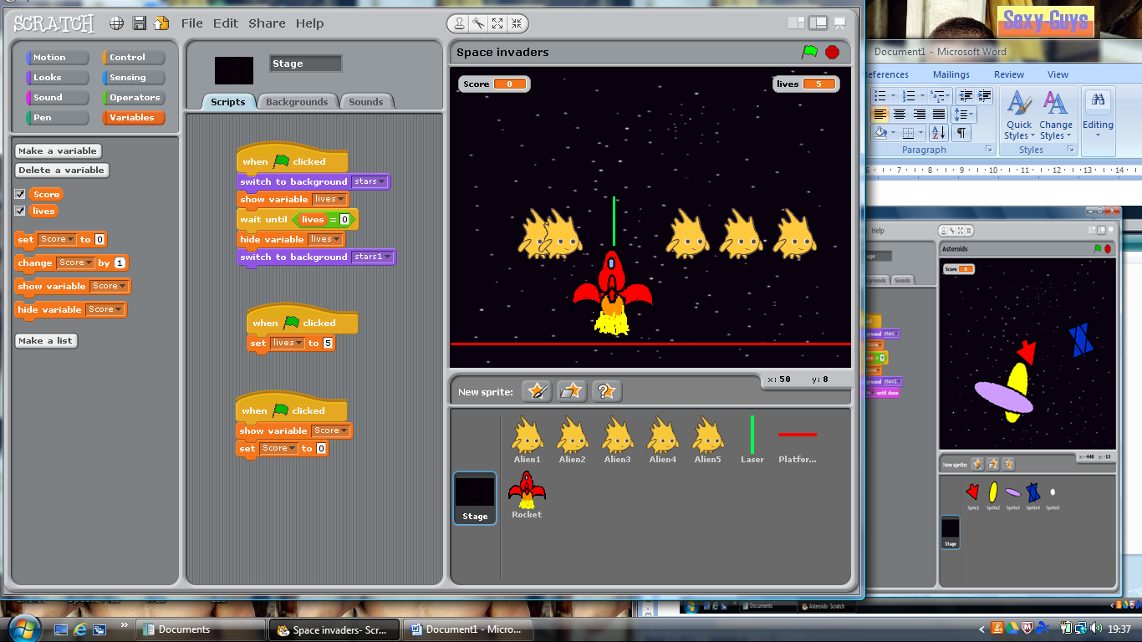**Space Invaders**

I have created a game called Space invader. The aim of the Game is to stop the aliens from hitting the ground by shooting them with a laser. Every Alien that I shoot allows me to gain 1 point and the aliens that hit the platform reduce my lives by -1.

I have created 8 different sprites

5 Alien Sprites 1 laser

1 Rocket Platform

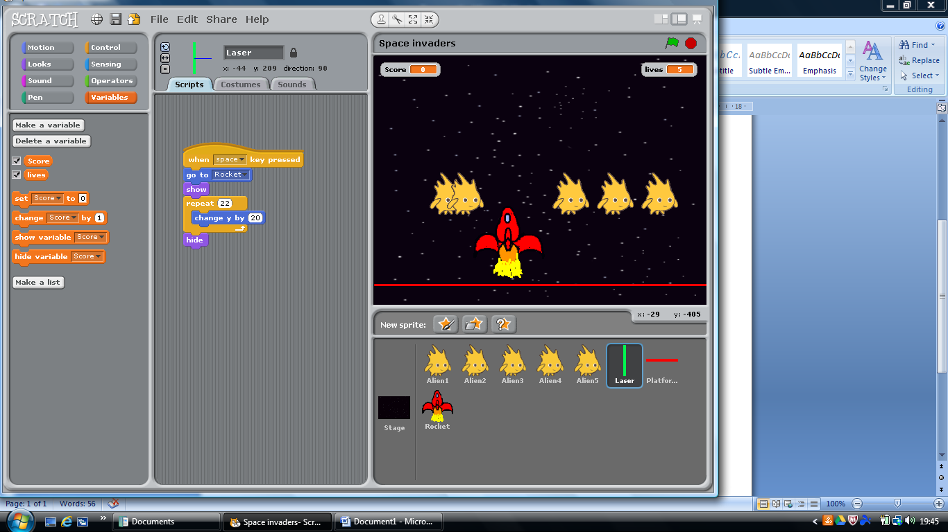

Examples of iteration and selection blocks

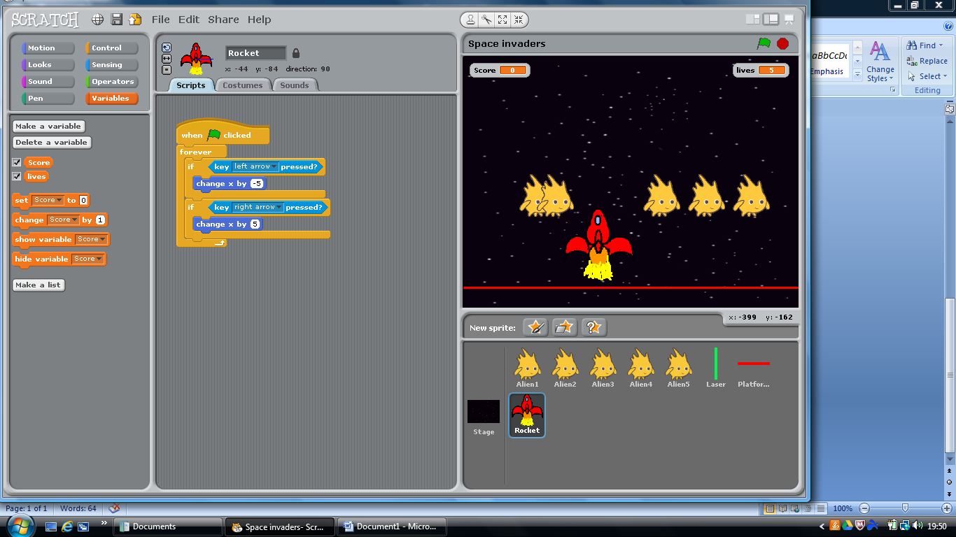

Changes that I made to the game

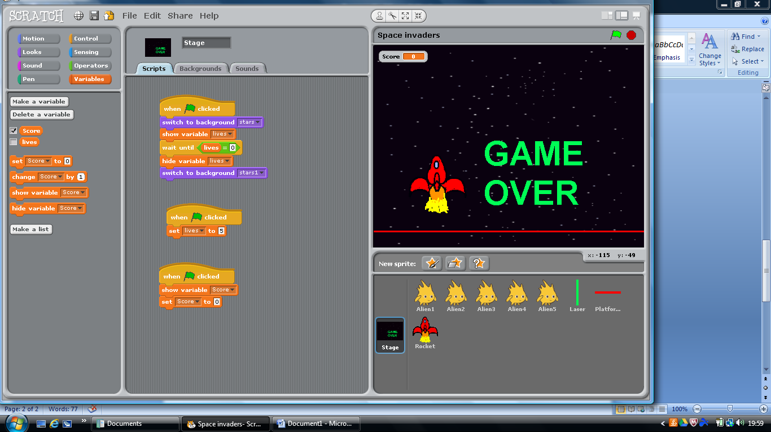I created two different backgrounds for the stage. If all of the lives are lost then the script will stop and it will switch to costume two which says ‘Game Over’